The LED turns on after a random delay and the Arduino records the start time using millis(). When the button is pressed, the time difference is calculated. This gives the user’s reaction time in milliseconds, which is displayed on the Serial Monitor.
link:https://www.tinkercad.com/things/6639hAS4fo2/editel?returnTo=%2Fdashboard%2Fdesigns%2Fcircuits&sharecode=MHnK_vCSARaQBdTqURYSq4XFmDqiLLL7sSJqNjSuMgg

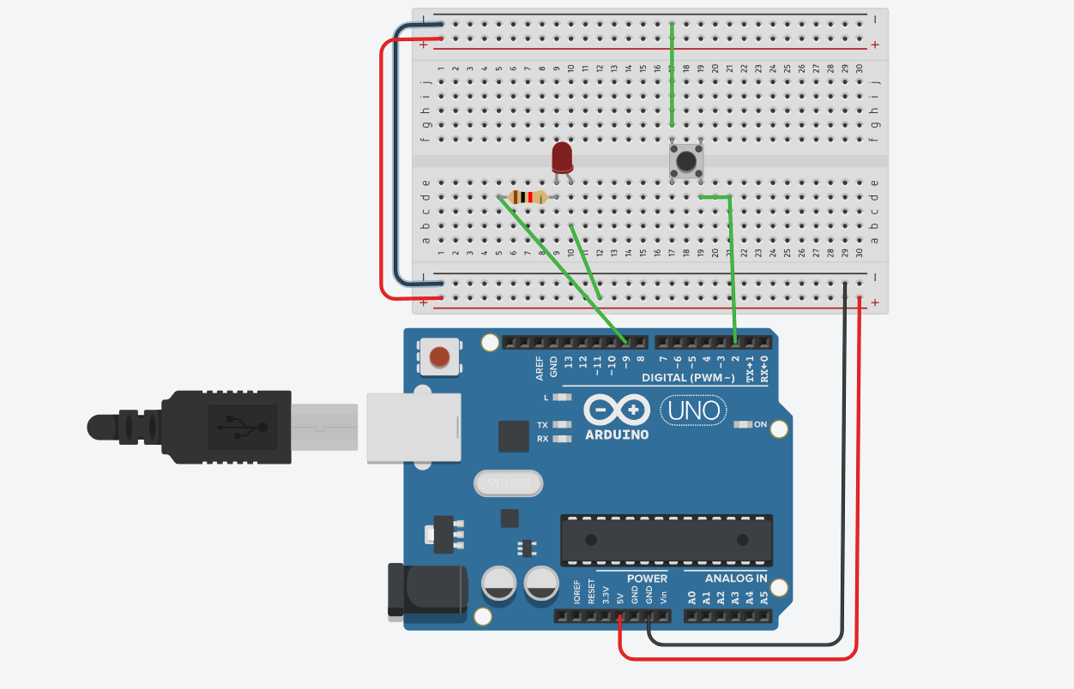

\Programe:
const int ledPin = 9;
const int buttonPin = 2;

unsigned long startTime = 0;
bool waitingForPress = false;

void setup() {
pinMode(ledPin, OUTPUT);
pinMode(buttonPin, INPUT_PULLUP);
Serial.begin(9600);
randomSeed(analogRead(0));
}

void loop() {

// Step 1: wait and turn ON LED
if (!waitingForPress) {
int waitTime = random(2000, 5000);
delay(waitTime);

digitalWrite(ledPin, HIGH);
startTime = millis();
waitingForPress = true;
}

// Step 2: wait for button press
if (waitingForPress && digitalRead(buttonPin) == LOW) {

unsigned long reactionTime = millis() - startTime;

Serial.print("Reaction Time: ");
Serial.print(reactionTime);
Serial.println(" ms");

digitalWrite(ledPin, LOW);
waitingForPress = false;

delay(1000); // small pause
}
}

